Convex Rectilinear Shapes
# Source: AI Source: Provided by: [Data Path: Persons Table -> ID Column: 1, Name_En Column: Motasem Essam] -> From: [ChatGPT] on [7/25/2026]
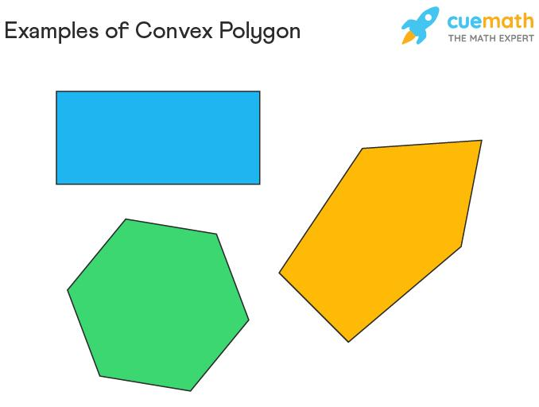
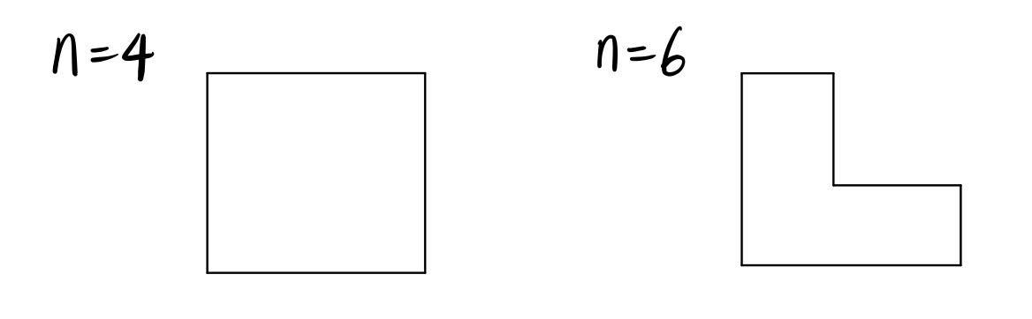
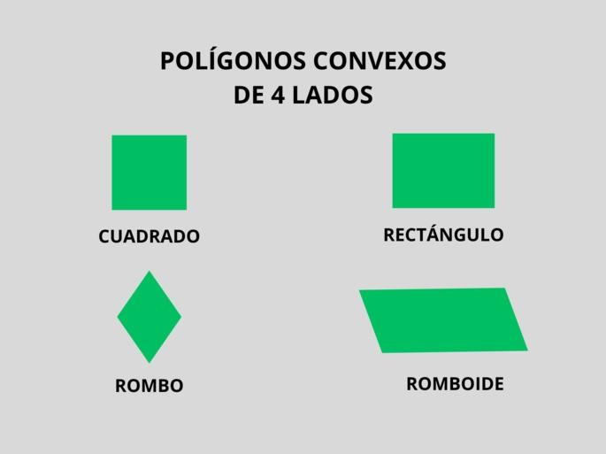

Definition
# Source: AI Source: Provided by: [Data Path: Persons Table -> ID Column: 1, Name_En Column: Motasem Essam] -> From: [ChatGPT] on [7/25/2026]
A Convex Rectilinear Shape is a rectilinear shape whose boundary consists of straight line segments meeting at right angles and which is convex.
A shape is convex if, for any two points inside the shape, the line segment connecting them lies entirely inside the shape.
For a convex rectilinear polygon, every interior angle is:
$$\boxed{{90}^{∘}}$$
and there are no inward indentations.

Fundamental Concept
# Source: AI Source: Provided by: [Data Path: Persons Table -> ID Column: 1, Name_En Column: Motasem Essam] -> From: [ChatGPT] on [7/25/2026]
A convex rectilinear shape combines two properties:
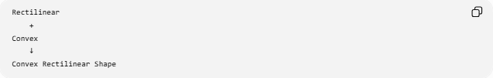
Rectilinear
+
Convex
↓
Convex Rectilinear Shape
Rectilinear
Its boundary is composed of straight segments arranged in horizontal and vertical directions.
Convex
It has no inward dents or indentations.
Therefore:
$$\boxed{\text{Convex Rectilinear Shape}=\text{Rectilinear Shape}+\text{Convexity}}$$

Main Characteristics
# Source: AI Source: Provided by: [Data Path: Persons Table -> ID Column: 1, Name_En Column: Motasem Essam] -> From: [ChatGPT] on [7/25/2026]
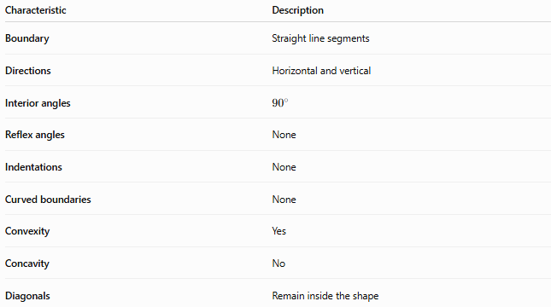
Characteristic | Description
Boundary | Straight line segments
Directions | Horizontal and vertical
Interior angles | $${90}^{∘}$$
Reflex angles | None
Indentations | None
Curved boundaries | None
Convexity | Yes
Concavity | No
Diagonals | Remain inside the shape

Basic Examples
# Source: AI Source: Provided by: [Data Path: Persons Table -> ID Column: 1, Name_En Column: Motasem Essam] -> From: [ChatGPT] on [7/25/2026]
Rectangle

┌──────────────┐
│ │
│ │
│ │
└──────────────┘
A rectangle is a convex rectilinear shape.
Square

┌────────┐
│ │
│ │
│ │
└────────┘
A square is also convex and rectilinear.

Important Property of Convex Rectilinear Polygons
# Source: AI Source: Provided by: [Data Path: Persons Table -> ID Column: 1, Name_En Column: Motasem Essam] -> From: [ChatGPT] on [7/25/2026]
For a simple convex rectilinear polygon, every interior angle is:
$$\boxed{{90}^{∘}}$$
There are no ${270}^{∘}$interior angles.
This distinguishes it from a concave rectilinear polygon, which contains at least one ${270}^{∘}$interior angle.

Number of Sides
# Source: AI Source: Provided by: [Data Path: Persons Table -> ID Column: 1, Name_En Column: Motasem Essam] -> From: [ChatGPT] on [7/25/2026]
A convex rectilinear polygon must have an even number of sides.
Examples include:
- 4 sides
- 6 sides
- 8 sides
- 10 sides
- 12 sides
- etc.
The simplest convex rectilinear polygon is a rectangle.
A square is the special case of a rectangle with all four sides equal.

Classification
# Source: AI Source: Provided by: [Data Path: Persons Table -> ID Column: 1, Name_En Column: Motasem Essam] -> From: [ChatGPT] on [7/25/2026]
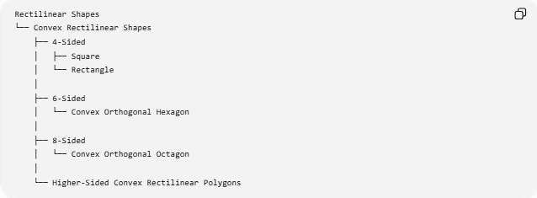
Rectilinear Shapes
└── Convex Rectilinear Shapes
├── 4-Sided
│ ├── Square
│ └── Rectangle
│
├── 6-Sided
│ └── Convex Orthogonal Hexagon
│
├── 8-Sided
│ └── Convex Orthogonal Octagon
│
└── Higher-Sided Convex Rectilinear Polygons
Note that not every convex rectilinear polygon with more than four sides is a commonly named standard polygon.

Why the Number of Sides Is Even
# Source: AI Source: Provided by: [Data Path: Persons Table -> ID Column: 1, Name_En Column: Motasem Essam] -> From: [ChatGPT] on [7/25/2026]
In a closed rectilinear polygon, horizontal and vertical sides must alternate through the boundary in terms of directional changes.
Every horizontal movement must ultimately be balanced by movement in the opposite horizontal direction, and the same applies vertically.
Consequently, the number of sides must be even:
$$\boxed{n=2k, k≥2}$$
where $k$is a positive integer.

Interior Angle Sum
# Source: AI Source: Provided by: [Data Path: Persons Table -> ID Column: 1, Name_En Column: Motasem Essam] -> From: [ChatGPT] on [7/25/2026]
For any simple $n$-sided polygon:
$$S=\left(n-2\right){180}^{∘}$$
For a convex rectilinear polygon, all $n$interior angles are ${90}^{∘}$.
Therefore:
$$S=n\left({90}^{∘}\right)$$
Equating the two expressions:
$$n\left({90}^{∘}\right)=\left(n-2\right){180}^{∘}$$
which gives:
$$\boxed{n\text{ is even}}$$

Perimeter
# Source: AI Source: Provided by: [Data Path: Persons Table -> ID Column: 1, Name_En Column: Motasem Essam] -> From: [ChatGPT] on [7/25/2026]
The perimeter is the sum of all side lengths:
$$\boxed{P=s_{1}+s_{2}+⋯+s_{n}}$$
Because the shape is closed and rectilinear:
$$\boxed{\text{Total horizontal length in one direction}=\text{Total horizontal length in the opposite direction}}$$
and:
$$\boxed{\text{Total vertical length in one direction}=\text{Total vertical length in the opposite direction}}$$
This can help determine missing side lengths.

Area
# Source: AI Source: Provided by: [Data Path: Persons Table -> ID Column: 1, Name_En Column: Motasem Essam] -> From: [ChatGPT] on [7/25/2026]
The area of a convex rectilinear shape can be calculated using several methods.
Rectangle
$$\boxed{A=lw}$$
where:
- $l$= length
- $w$= width
Decomposition
A more complex convex rectilinear shape can be divided into rectangles:
$$\boxed{A=A_{1}+A_{2}+⋯+A_{n}}$$
This is particularly useful when the shape contains multiple rectangular regions.

Convexity Test
# Source: AI Source: Provided by: [Data Path: Persons Table -> ID Column: 1, Name_En Column: Motasem Essam] -> From: [ChatGPT] on [7/25/2026]
A shape is convex if every line segment connecting any two points inside the shape remains inside it.
For a convex rectilinear polygon:
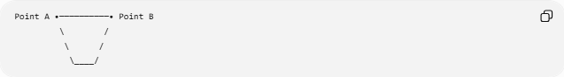
Point A •──────────• Point B
\ /
\ /
\____/
The connecting segment stays inside the polygon.
There are no inward indentations.

Convex vs Concave Rectilinear Shapes
# Source: AI Source: Provided by: [Data Path: Persons Table -> ID Column: 1, Name_En Column: Motasem Essam] -> From: [ChatGPT] on [7/25/2026]
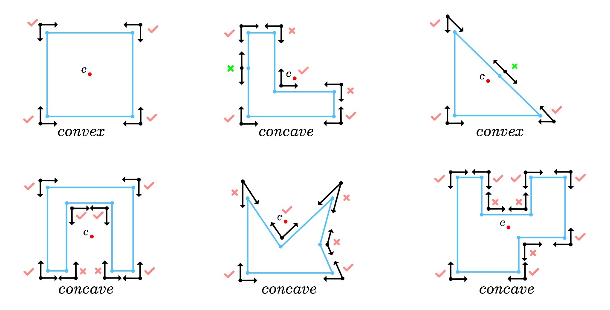
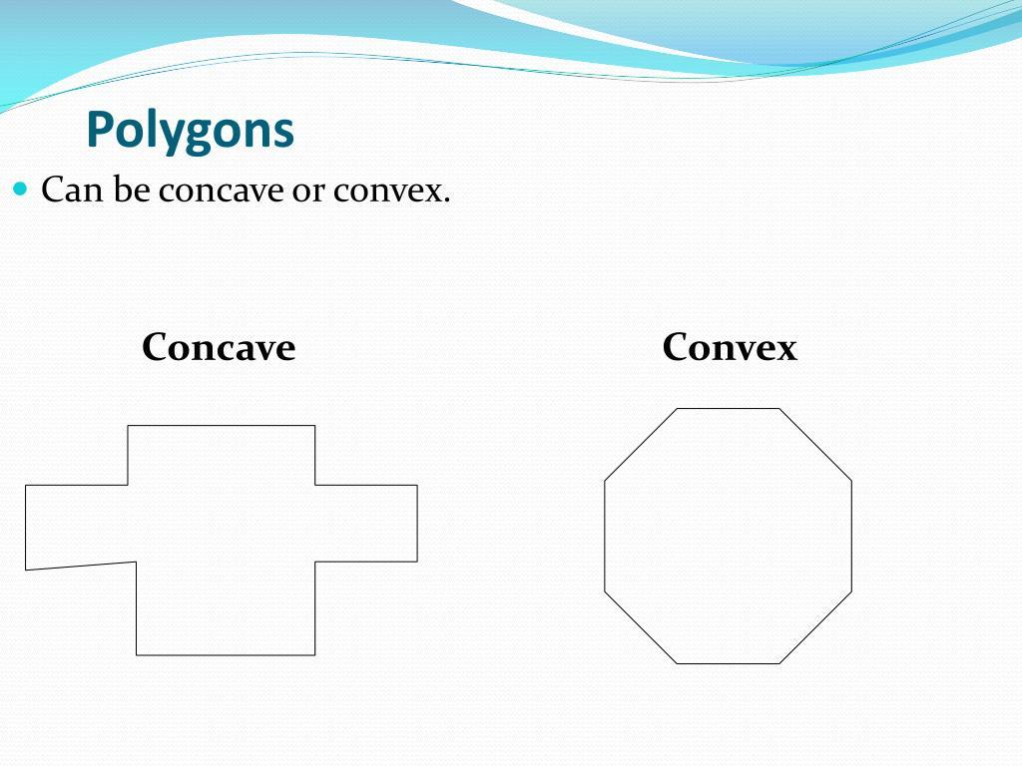
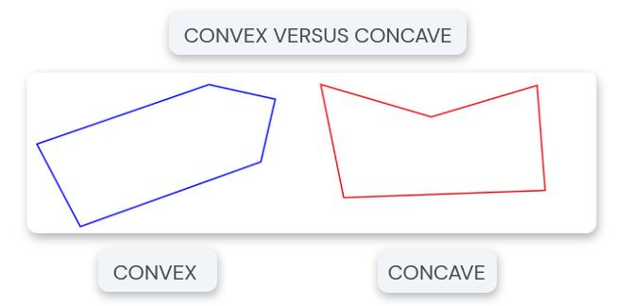
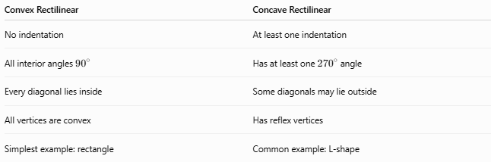
Convex Rectilinear | Concave Rectilinear
No indentation | At least one indentation
All interior angles ${90}^{∘}$ | Has at least one ${270}^{∘}$angle
Every diagonal lies inside | Some diagonals may lie outside
All vertices are convex | Has reflex vertices
Simplest example: rectangle | Common example: L-shape

Convex Rectilinear Shape vs Rectangle
# Source: AI Source: Provided by: [Data Path: Persons Table -> ID Column: 1, Name_En Column: Motasem Essam] -> From: [ChatGPT] on [7/25/2026]
A rectangle is always a convex rectilinear shape.
However, not every convex rectilinear shape is a rectangle.
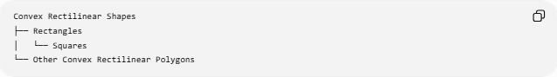
Convex Rectilinear Shapes
├── Rectangles
│ └── Squares
└── Other Convex Rectilinear Polygons
Thus:
$$\boxed{\text{Rectangle}⊂\text{Convex Rectilinear Shapes}}$$

Convex Rectilinear Shape vs Regular Shape
# Source: AI Source: Provided by: [Data Path: Persons Table -> ID Column: 1, Name_En Column: Motasem Essam] -> From: [ChatGPT] on [7/25/2026]
A convex rectilinear shape does not have to be regular.
For example, a rectangle with unequal side lengths is:
- Convex
- Rectilinear
- Not a regular polygon
A square is:
- Convex
- Rectilinear
- Regular

Examples
# Source: AI Source: Provided by: [Data Path: Persons Table -> ID Column: 1, Name_En Column: Motasem Essam] -> From: [ChatGPT] on [7/25/2026]
Common examples include:
- Square
- Rectangle
- Convex orthogonal hexagon
- Convex orthogonal octagon
- Other convex polygons with horizontal and vertical sides
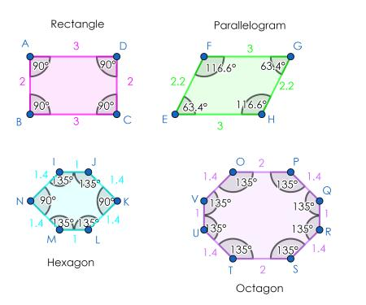
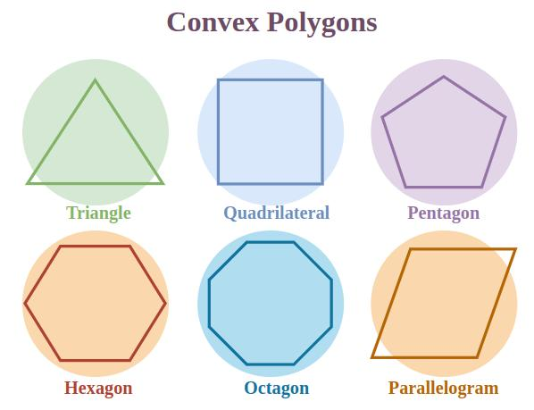
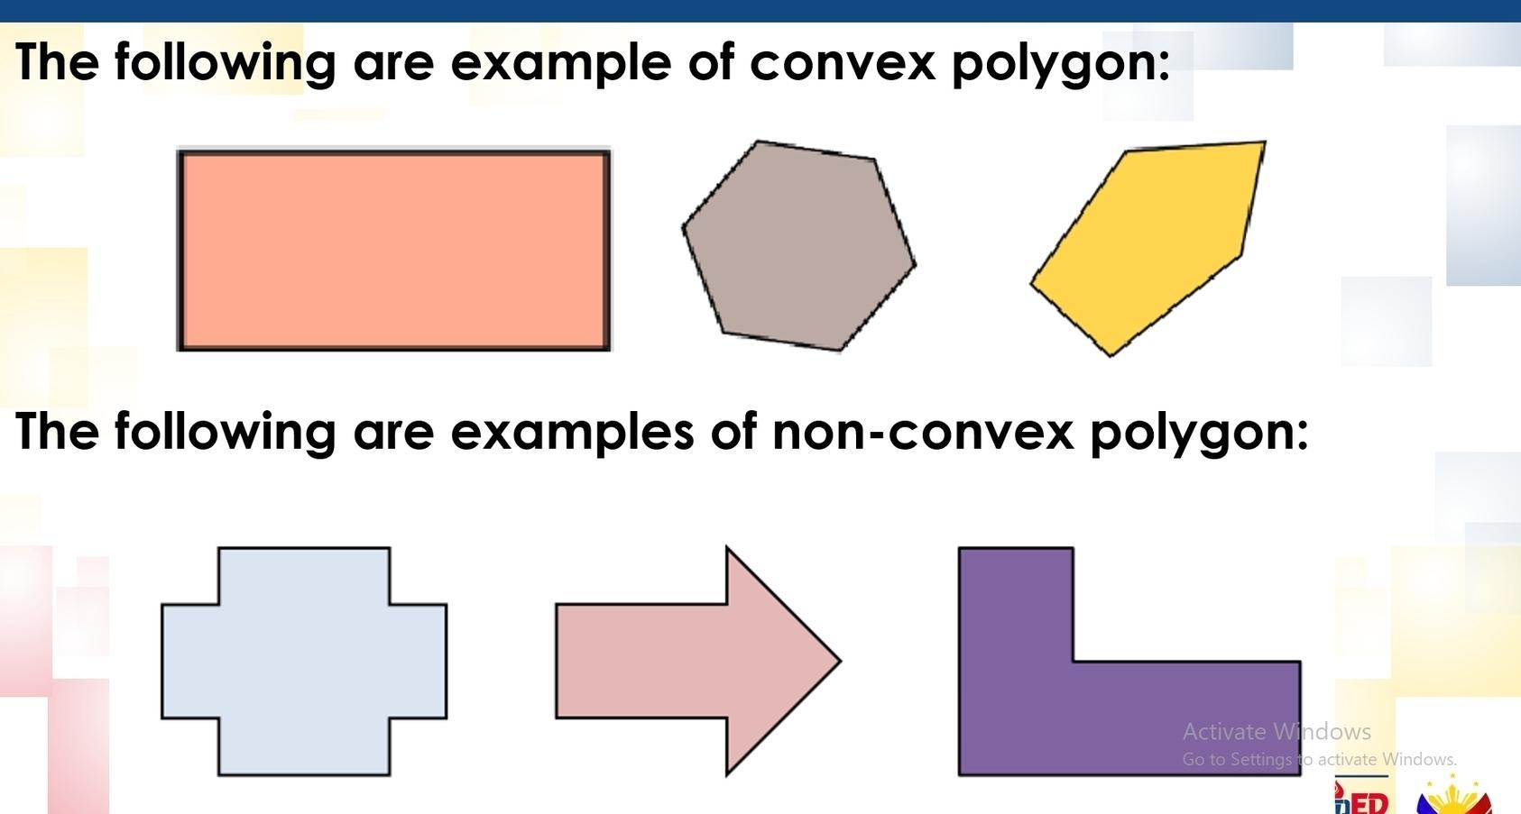

Classification Summary
# Source: AI Source: Provided by: [Data Path: Persons Table -> ID Column: 1, Name_En Column: Motasem Essam] -> From: [ChatGPT] on [7/25/2026]
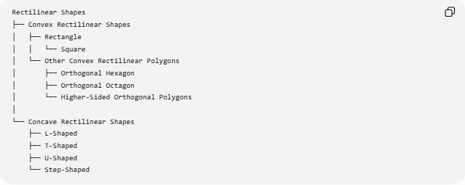
Rectilinear Shapes
├── Convex Rectilinear Shapes
│ ├── Rectangle
│ │ └── Square
│ └── Other Convex Rectilinear Polygons
│ ├── Orthogonal Hexagon
│ ├── Orthogonal Octagon
│ └── Higher-Sided Orthogonal Polygons
│
└── Concave Rectilinear Shapes
├── L-Shaped
├── T-Shaped
├── U-Shaped
└── Step-Shaped

Key Points
# Source: AI Source: Provided by: [Data Path: Persons Table -> ID Column: 1, Name_En Column: Motasem Essam] -> From: [ChatGPT] on [7/25/2026]
- A Convex Rectilinear Shape has a straight-line boundary arranged in perpendicular directions and contains no indentation.
- Every interior angle of a simple convex rectilinear polygon is:
$${90}^{∘}$$
- It has no reflex ${270}^{∘}$angles.
- A convex rectilinear polygon has an even number of sides.
- A rectangle is the simplest general example.
- A square is a special regular example.
- More complex convex rectilinear polygons can have 6, 8, 10, or more sides.
- Every diagonal of a convex polygon lies entirely inside the polygon.
- Its area can often be found by decomposing it into rectangles.

Conclusion
# Source: AI Source: Provided by: [Data Path: Persons Table -> ID Column: 1, Name_En Column: Motasem Essam] -> From: [ChatGPT] on [7/25/2026]
A Convex Rectilinear Shape is a convex shape whose boundary is composed entirely of straight, perpendicular segments. In a closed polygonal form, all its interior angles are ${90}^{∘}$, it has no inward indentations, and its number of sides is necessarily even. Squares, rectangles, and convex orthogonal polygons are important examples.

